Moving Part Accessibility and Pinch Point Test
  - Test procedure based on EN 62368-1:2014 Clause 8.5 and Annex V

Purpose
This procedure explains how to determine whether a finger can reach a moving pinch point through an enclosure hole and how to record a pass or fail result. The applicable standardized test probe must be used; a person must never place a real finger into the opening during the assessment.
Main conclusion If the applicable Annex V probe can contact a moving part classified as MS2 or MS3, the construction normally fails Clause 8.5. An equipment safeguard must prevent access, or a compliant interlock must reduce the movement to MS1 before access becomes possible.
Document type | Laboratory test procedure and record
Product | [Enter product and model]
Opening reference | [Enter drawing or photograph reference]
Applicable person | Ordinary person unless justified otherwise
Standard basis | EN 62368-1:2014, particularly 8.2, 8.3, 8.5 and Annex V

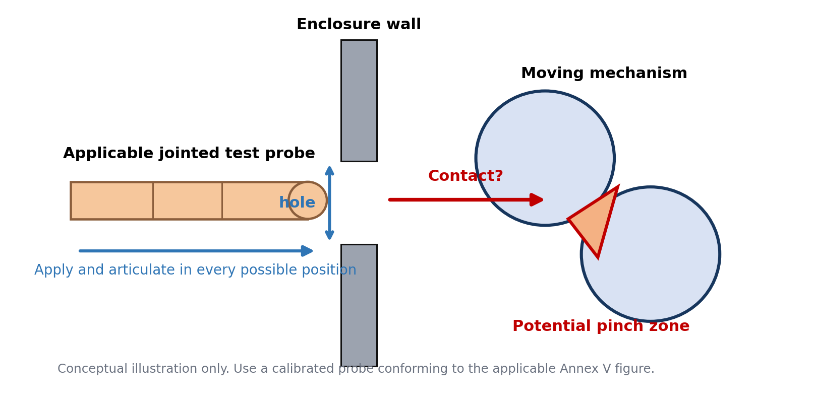
Figure 1 Concept of accessibility through a hole to a pinch point

Scope and decision rule
The procedure applies to a hole, slot or similar opening through which a person could reach a moving mechanism. Examples include gears, rollers, linkages, belts, cams and sliding components that can trap or pinch a finger.
Two questions must be answered separately:
1. Can the applicable test probe contact the moving part or enter its motion or pinch zone?
2. Is the moving part MS1, MS2 or MS3 under normal operation, abnormal operation and relevant single fault conditions?
A hole that accepts a real finger is a strong indication that formal testing is required, but the result must be based on the standardized probe. Accessibility does not by itself establish failure if the contacted moving part is demonstrated to remain MS1.

Relevant requirements
Reference | Subject | Use in this assessment
8.2 and Table 35 | Mechanical source classification | Classify a general moving part using Table 35 line 2.
8.3 | Mechanical safeguards | Apply the general protection requirements for ordinary, instructed and skilled persons.
8.5.1 | Moving parts | Covers pinch points, meshing gears and unexpected movement. MS2 and MS3 parts normally require an equipment safeguard against finger entry or entanglement.
8.5.3 | Compliance | Check accessibility by inspection and, where necessary, by the relevant Annex V methods.
Annex V.1.2 | Jointed probes | Apply the applicable jointed probe to surfaces and openings in every possible position.
Annex V.1.3 | Straight probes | Use the corresponding straight probe at up to 30 N when the jointed probe does not initially gain access.
Annex K | Safety interlocks | Where an interlock is the safeguard, movement must be reduced to MS1 before the part is accessible.

Important limitation
EN 62368-1 does not provide one universal pinch-force value for all moving mechanisms. The classification of general moving parts relies on the outcome described by Table 35 and on engineering judgement. Shape, speed, available force or torque, closing gap, cycle, likelihood of trapping, elasticity and the affected body part all influence the classification.

Probe selection
Select the jointed probe according to whether children are likely to have access to the equipment. The product location must be supported by the intended-use instructions and the real installation. A workplace label alone does not necessarily establish that children are unlikely to have access.
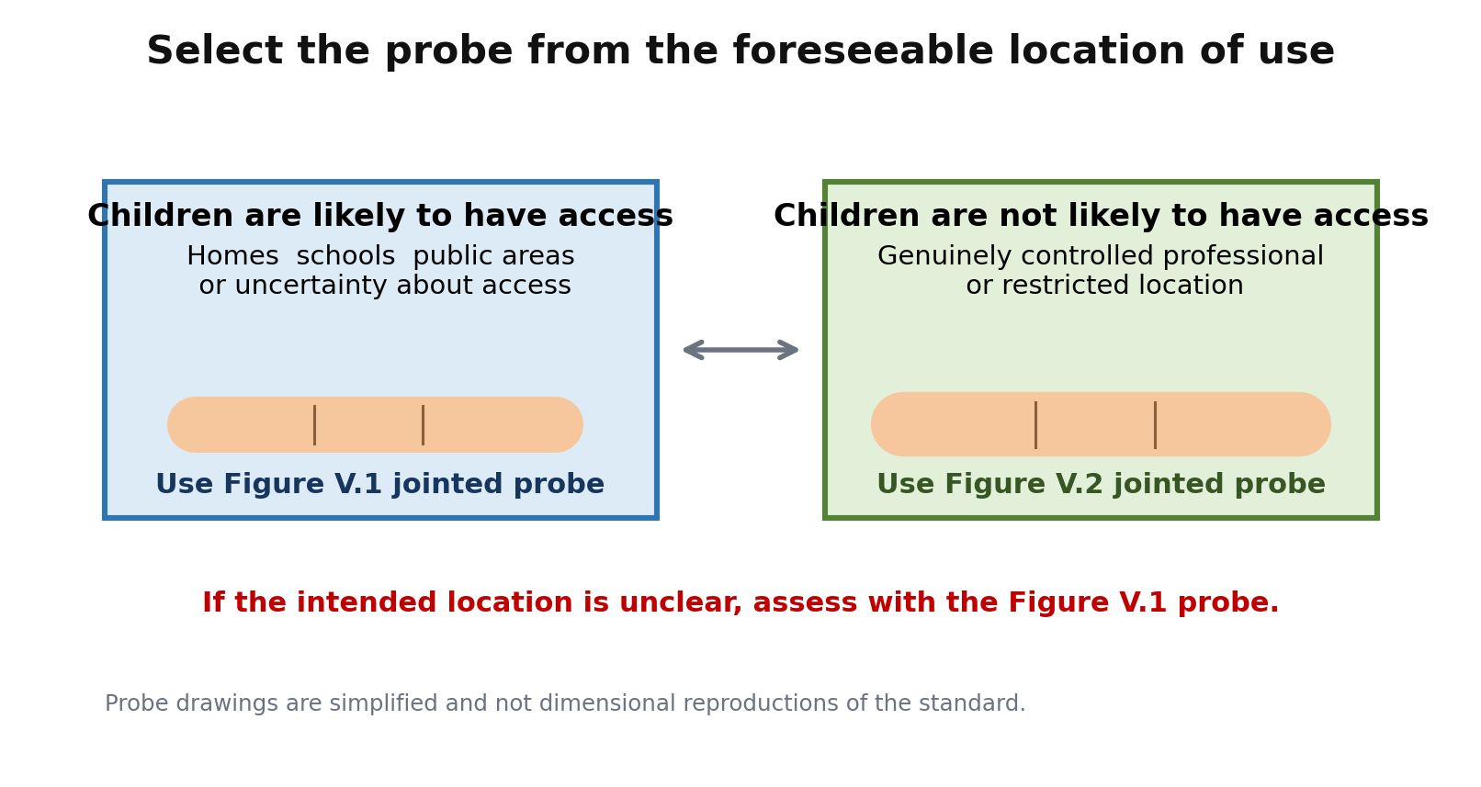
Figure 2 Selection of the applicable jointed test probe

Required equipment
Item | Requirement | Purpose
Jointed probe | Probe conforming to Figure V.1 or V.2 as applicable | Initial accessibility test
Straight probe | Unjointed version corresponding to the selected jointed probe | Conditional 30 N opening test
Force gauge | Suitable range and current calibration | Control and record the 30 N application
Contact indication | Low-energy continuity circuit, removable transfer medium or clear visual method | Determine contact without exposing the tester to the mechanism
Camera and scale | Photograph or video with a dimensional scale | Evidence of opening, probe orientation and contact result
Isolation and controls | Safe isolation, remote start and emergency stop | Personnel safety during powered checks

Test preparation
Do not substitute an actual finger, an IP test probe selected for another standard, or an unverified homemade gauge for the specified Annex V probe when claiming compliance.
1. Identify the foreseeable user. Unless access is restricted and justified, treat the operator as an ordinary person.
2. Identify whether the product is likely to be accessible to children and select Figure V.1 or Figure V.2 accordingly.
3. Install the equipment exactly as instructed. Fit required brackets, panels and external accessories.
4. Place doors, covers, controls, adjustable parts and removable user parts in every position available without a tool. Also follow any instruction that directs a person to open or remove a part, even if a tool is specified.
5. Record the hole dimensions, wall thickness, distance to the moving part and minimum pinch gap. Photograph the opening.
6. Identify the complete motion envelope, including coast-down, restart, unexpected reset and movement following a relevant single fault.
7. For the geometric reach test, isolate the equipment and prevent unexpected movement. Place the mechanism at each worst-case point in its cycle where this can be done without changing the geometry.
8. Prepare a safe contact-indication method. Do not energize the mechanism merely to see whether it pinches the test probe.

Safety during the assessment
The standardized probe represents a body part; it is not permission to expose the tester to the hazard. Establish physical isolation for reach measurements. Interlock and stopping-time checks may require powered operation, but they should be conducted using guarded remote controls, suitable instrumentation and an emergency stop. Stop immediately if the probe could be drawn into or damaged by the mechanism.

Accessibility test method
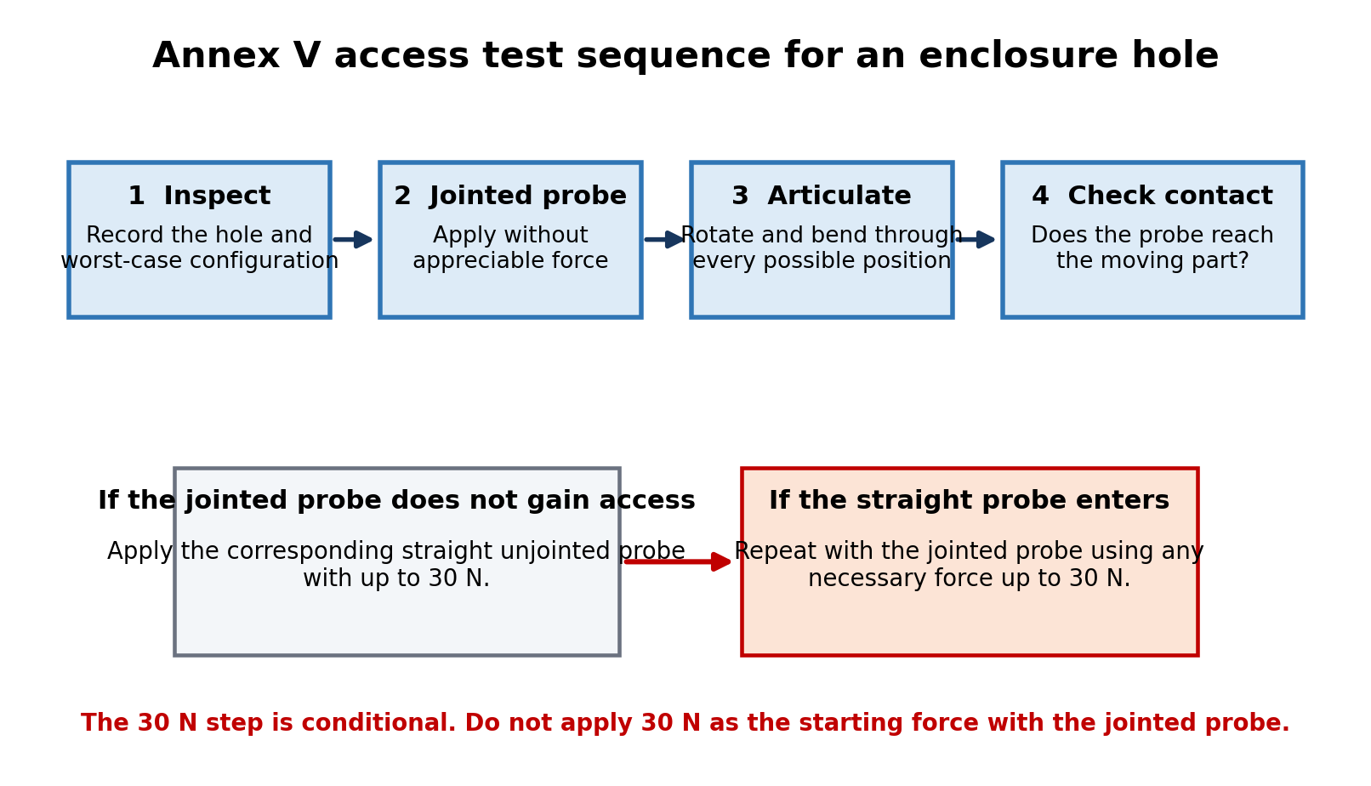
Figure 3 Annex V sequence for the jointed and straight probes

Initial jointed probe test
1. Apply the selected jointed probe to the hole without appreciable force. Do not force it through the opening during this initial step.
2. Rotate the probe around the full perimeter. Angle it upward, downward and sideways. Bend both joints through all useful positions and repeat from every approach that could reach the moving mechanism.
3. Where the probe passes through the opening, explore the full reachable volume. Do not use the enclosure edge as an artificial stop unless the probe geometry naturally bears against it.
4. Repeat with the mechanism placed at each worst-case position in its travel. Include positions that create the smallest trapping gap or place the part nearest the opening.
5. Record whether any part of the probe touches the moving part or enters the area swept by it. Contact with the hazardous motion envelope counts as access even if the mechanism was safely stationary for the geometric check.

Conditional straight probe test
Perform this step only where the applicable jointed probe does not gain access to the part:
1. Apply the corresponding straight unjointed probe to the opening with a steadily increased force up to 30 N in the direction most likely to enlarge or penetrate the opening.
2. If the straight probe does not enter sufficiently to challenge the safeguard, record the result and stop this sequence.
3. If the straight probe enters, repeat the access test with the corresponding jointed probe. Use only the force necessary, up to 30 N, and articulate it through every possible position.
4. Inspect the enclosure after the force test. Repeat the jointed-probe accessibility check if the opening, guard or surrounding material has permanently deformed.

Large openings
If the complete probe can pass through an opening large enough for an arm but not a shoulder, Annex V requires assessment within the specified 762 mm radius hemisphere behind the opening. This is unlikely to be the relevant case for a small finger-sized hole, but it should be checked if the opening is larger than first assumed.

Mechanical source classification
Classify the moving part separately from the accessibility test. For a general pinch mechanism, use Table 35 line 2 together with Clauses 8.2 and 8.5. Do not classify the source solely from motor wattage or the fact that the mechanism moves slowly.
Class | Typical body response | Pinch-point interpretation | Evidence to record
MS1 | No pain or injury expected | Movement cannot produce a painful pinch in the applicable conditions. Under single fault, it does not exceed the permitted MS1 rule in 8.2.2. | Force or torque, gap, speed, affected body part, cycle and fault analysis
MS2 | Pain may occur, but injury is not expected | The pinch can be painful or cause a withdrawal reaction but is not expected to require medical treatment. | Engineering assessment, representative testing and justification against Table 35 line 2
MS3 | Injury may occur | The mechanism can crush, cut, trap or otherwise injure a finger. Medical or emergency attention may be needed. | Worst-case measurements, injury mechanism, stopping behaviour and fault conditions

Factors that should be considered
- Maximum closing force and torque at the pinch point, including stall or jam conditions.
- Closing speed, kinetic energy, available travel and whether force is maintained after trapping.
- Minimum gap, edge radius, contact area and whether the mechanism can cut as well as pinch.
- Whether the finger can be drawn further into rollers, gears or belts.
- Automatic restart, intermittent movement and unexpected reset of a control or protective device.
- Normal operation, abnormal operation and every relevant single fault condition.
- The person and body part likely to be exposed, including children where applicable.
If the actual mechanism has already pinched a finger, caused bruising, broken skin, trapping or similar effects, do not assume MS1. Treat it conservatively as at least MS2, and potentially MS3, until a competent product-safety assessment establishes the classification.

Pass and fail criteria
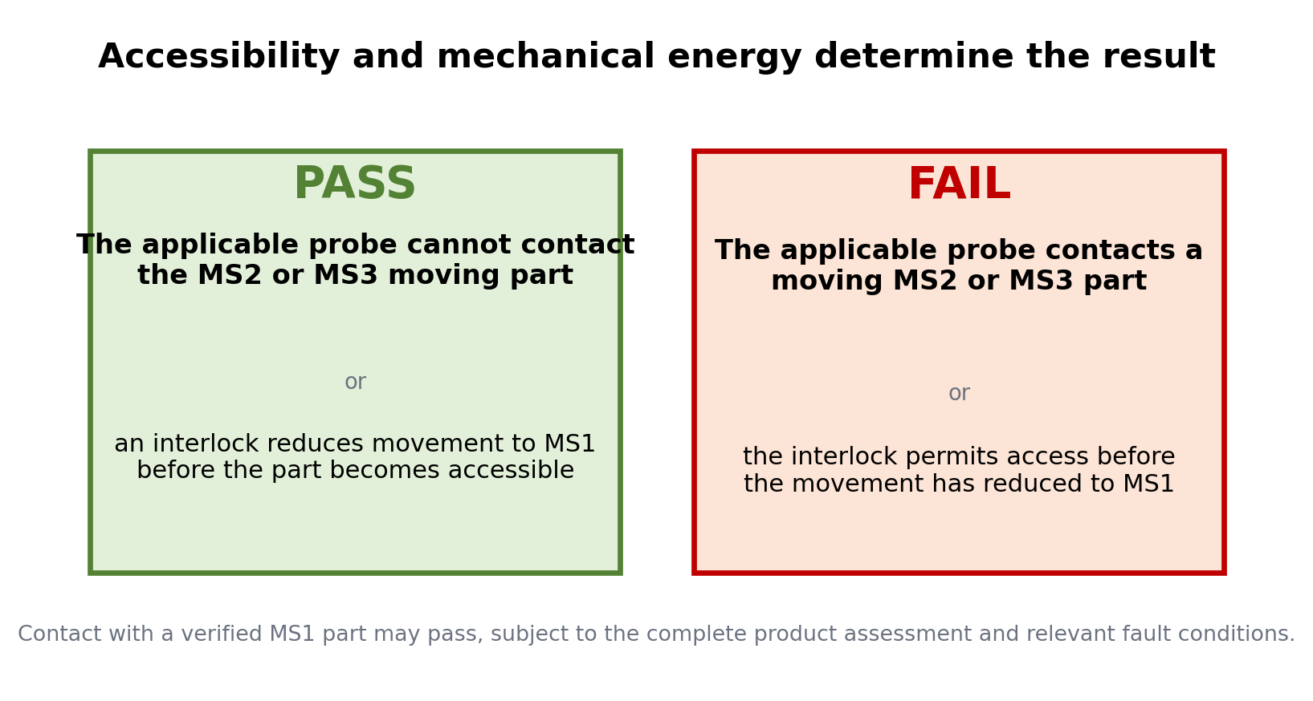
Figure 4 Principal pass and fail criteria for an ordinary person
Observed result | Decision | Reason
Probe cannot contact or enter the motion zone of an MS2 or MS3 part in any applicable configuration. | PASS | The enclosure or guard acts as the equipment safeguard.
Probe contacts a part demonstrated to remain MS1 under the applicable operating and fault conditions. | PASS subject to full assessment | MS1 contact is generally permitted, but all other clauses and safeguards still apply.
Probe contacts or enters the motion zone of an MS2 or MS3 pinch point. | FAIL | Clause 8.5 normally requires an equipment safeguard to prevent finger entry or contact.
Opening deforms during the straight-probe test and the repeated jointed probe then reaches an MS2 or MS3 part. | FAIL | The safeguard does not remain effective under the Annex V force sequence.
Interlock opens access only after the moving part has reduced to MS1. | PASS subject to Annex K | The interlock must meet Annex K and remain effective under relevant faults.
Interlock allows the probe to reach the part while it remains MS2 or MS3 or during coast-down. | FAIL | Movement has not reduced to MS1 before accessibility.
Only a warning label is added while an ordinary person can still reach a non-essential MS2 or MS3 pinch point. | FAIL | An instructional safeguard does not normally replace the required equipment safeguard.

Limited functional exception
Clause 8.5 contains conditions for a moving MS2 or MS3 part that must remain accessible for the intended function. This is a narrow exception, not the normal route for an incidental hole. The exposure must not be life threatening, the movement must be obvious, guarding must be maximized, the prescribed instructional safeguard must be used and an accessible MS3 part requires the specified nearby stopping device. A certification body or competent safety engineer should review any reliance on this exception.

Corrective actions following a failure
Where the test probe reaches an MS2 or MS3 pinch point, correct the construction and repeat the full assessment. Suitable design options include:
- Reduce the hole or change its geometry so that the applicable jointed and straight probes cannot reach the moving part.
- Add an internal finger guard, tunnel or baffle that remains secure and does not create another pinch or sharp-edge hazard.
- Increase the distance between the opening and the complete motion envelope.
- Reduce closing force, torque, speed or stored energy so the mechanism is demonstrably MS1 in normal, abnormal and relevant single fault conditions.
- Add a safety interlock complying with Annex K. The movement must reduce to MS1 before access is possible, including during coast-down.
- Prevent unexpected restart and consider trapped-finger release where the mechanism can hold force after stopping.
After modification, repeat the Annex V tests in every direction and configuration. Also repeat any enclosure robustness, abnormal-operation, single-fault and interlock tests that could affect accessibility.

Recommended immediate action for the described hole
Because a real finger can enter and the mechanism can pinch, stop treating the opening as inherently safe. Perform the applicable Figure V.1 or V.2 jointed-probe test first. If the probe reaches the pinch point, classify the mechanism. Unless it is supported as MS1, redesign the opening or add a guard or compliant interlock before declaring conformity.

Test record
Record field | Entry
Product and model
Sample serial number
Drawing and opening reference
Test date
Tester
Intended installation
Children likely to have access | Yes / No / Uncertain
Selected probe | Figure V.1 / Figure V.2
Probe identification and calibration
Opening dimensions
Distance to moving part
Mechanism and motion description
Operating conditions assessed | Normal / Abnormal / Single fault
Mechanical classification | MS1 / MS2 / MS3
Classification evidence reference
Jointed probe contact | Yes / No
Straight probe at up to 30 N required | Yes / No
Straight probe entered | Yes / No / Not applicable
Repeated jointed probe contact | Yes / No / Not applicable
Interlock provided | Yes / No
Movement reduced to MS1 before access | Yes / No / Not applicable
Final result | PASS / FAIL
Corrective action and retest reference

Photographic evidence
Attach photographs showing the opening, probe identity, each worst-case probe orientation, contact indication, mechanism position and any deformation following the 30 N test.

References and cautions
Primary standard references
- IEC 62368-1:2014 Edition 2 information page IEC Webstore
- IEC 62368-1:2014 official preview, including the contents identifying Clauses 8.2, 8.3, 8.5 and Annex V IEC preview distributed through ANSI
- BS EN 62368-1:2014+A11:2017 status BSI Knowledge

Use of this procedure
This document is an explanatory laboratory aid and does not reproduce every requirement, dimensional tolerance or exception in the standard. Use a legally obtained copy of the applicable edition, its amendments and corrigenda when performing a conformity assessment. Where a product is being newly certified, confirm which edition and national or European amendments are required for the target market. BSI lists BS EN 62368-1:2014+A11:2017 as withdrawn.
Prepared for practical assessment of a finger-accessible opening adjacent to a moving pinch mechanism.

